**Excel Assignment – 6**

1. What are the various elements of the Excel interface?

Describe how they're used.

🡪 Microsoft Excel XP is a spreadsheet application in the Microsoft Office suite.

A spreadsheet is an accounting program for the computer. The primary

purpose of a spreadsheet is to work with numbers and text. Spreadsheets can

be used to organize data like alphabetizing a list of named or sorting records,

as well as to calculate and analyse data using mathematical formulas.

The following are the basic parts of the Microsoft Excel Window:

Quick Access Toolbar, File Tab, Title Bar, Buttons, Menu Bar, Ribbon/Toolbar,

Dialog Box Launcher, Name Box, Formula Bar, Scroll Bars, Spreadsheet Area, Leaf

Bar, Column Bar, Row Bar Cells, Cells, Status Bar, View Buttons, Zoom control.

2. Write down the various applications of Excel in the industry.

🡪 MS Excel or Microsoft Excel is an essential software program of Microsoft.

Office Suite developed by Microsoft. It is one of the most powerful

spreadsheet software that uses rows and columns to organize the data.

Uses of Microsoft Excel: Data Entry and Storage, Performing Calculations, Data

Analysis, and Interpretation, Reporting and Visualizations, Accounting and

Budgeting, Collection and Verification of Business Data, Calendars and

Schedules, Administrative and Managerial Duties, Forecasting, Automating

Repetitive Tasks

3. On the ribbon, make a new tab. Add some different groups,

insert commands in the groups and name them according.

to the commands added. Copy and paste the screenshot of

the steps you followed.

🡪 First right click on the tab button → choose custom the ribbon, then follows

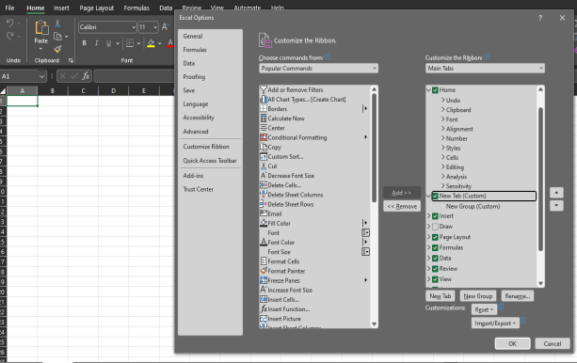

4. Make a list of different shortcut keys that are only

🡪 connected to formatting with their functions.

Here are my top five Excel formatting shortcuts:

CONTROL + B: Applies bold font formatting to headers

ALT + H + B + A: Applies borders to the cells

ALT + H + B + T: Gives an outline border to the dataset

ALT + H + O + W: Autofits column widths

CONTROL + 1: Opens Format Cells dialog box.

5. What distinguishes Excel from other analytical tools?

🡪 Data processing work under general office requirements and Data

management and storage of small and medium-sized companies.

Simple statistical analysis for students or teachers (such as analysis of

variance, regression analysis, etc.). Assistant tool of data analysts.

Production of charts for some business magazines and newspapers (data

visualization).

Advantages

It’s easy to get started with Excel.

The learning resources are very rich.

You can do a lot of things with Excel: modelling, visualization, reports,

dynamic charts, etc.

It can help you understand the meaning of many operations before further

learning other tools (such as Python and R).

6. Create a table and add a custom header and footer to your

table.

🡪 On the view tab→click page break preview →click header format then

Header & Footer tab will display.

Excel displays the worksheet in a page break preview. To add or edit a header

or footer, click the left, center, or right header or footer text box at the top or

the bottom of the worksheet page (under the Header, or above the Footer).

Type the new header or footer text.

A header is a text that is placed at the top of a page, while a footer is placed

at the bottom, or foot, of a page. Typically, these areas are used for inserting

document information, such as the name of the document, the chapter

heading, page numbers, the creation date, and the like.